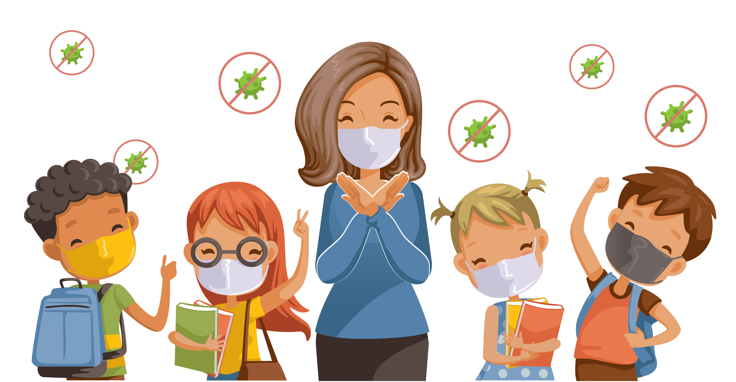  Date  School Located Vaccine Event(SLVE)  Notice of Upcoming Vaccination Event  Dear Staff,  Vaccinating students at school can help meet the demand for convenient, timely vaccination of school-aged children while decreasing the burden on local health care providers who may be busy treating those infected with COVID-19 and/or seasonal influenza.  This letter is to inform you that our school is planning to hold a school-located [COVID-19] vaccination event on [date]. We will be contacting parents/ guardians and sending them information about the vaccine, the disease, and the vaccination event. We will also be requesting that they return completed consent forms for receipt of the vaccine. Parents/ guardians can either consent to or decline the vaccine on the consent form. If parents/ guardians decline or do not submit a consent form their student will not be vaccinated. If you have any questions or would like to assist with the event, please contact [Lead Supervisor of vaccine event]. | Free COVID-19 Vaccines.  ────  Vaccinators will be giving the COVID-19 vaccine during the school day.  ────  Students are expected to need [two doses] of the vaccine, spaced about [3 weeks apart].  Organization  Street Address  City, ST ZIP Code  Telephone  Web Address

